Brandon Cao

CIS 425

Spring 16’

**Assignment 1**

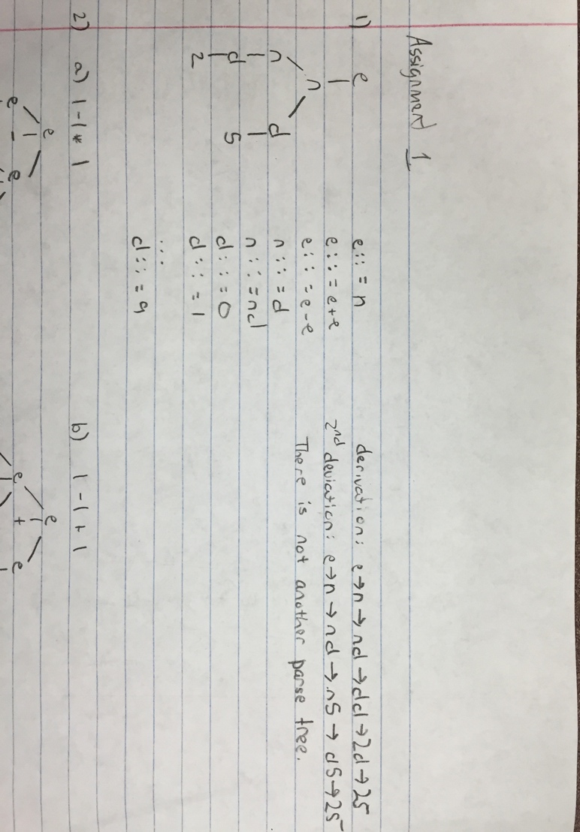

2)

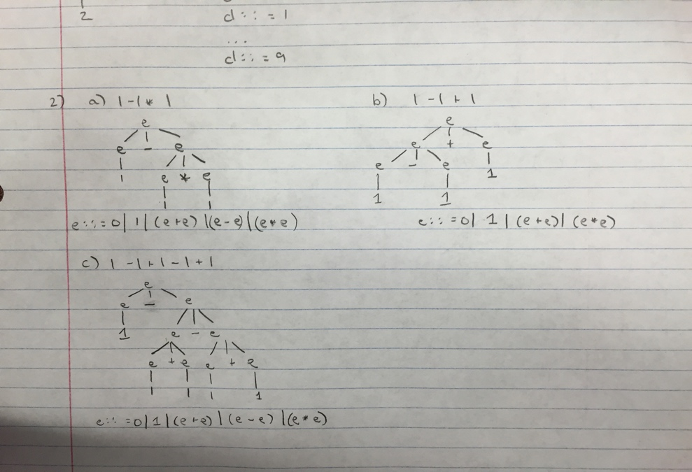

3)

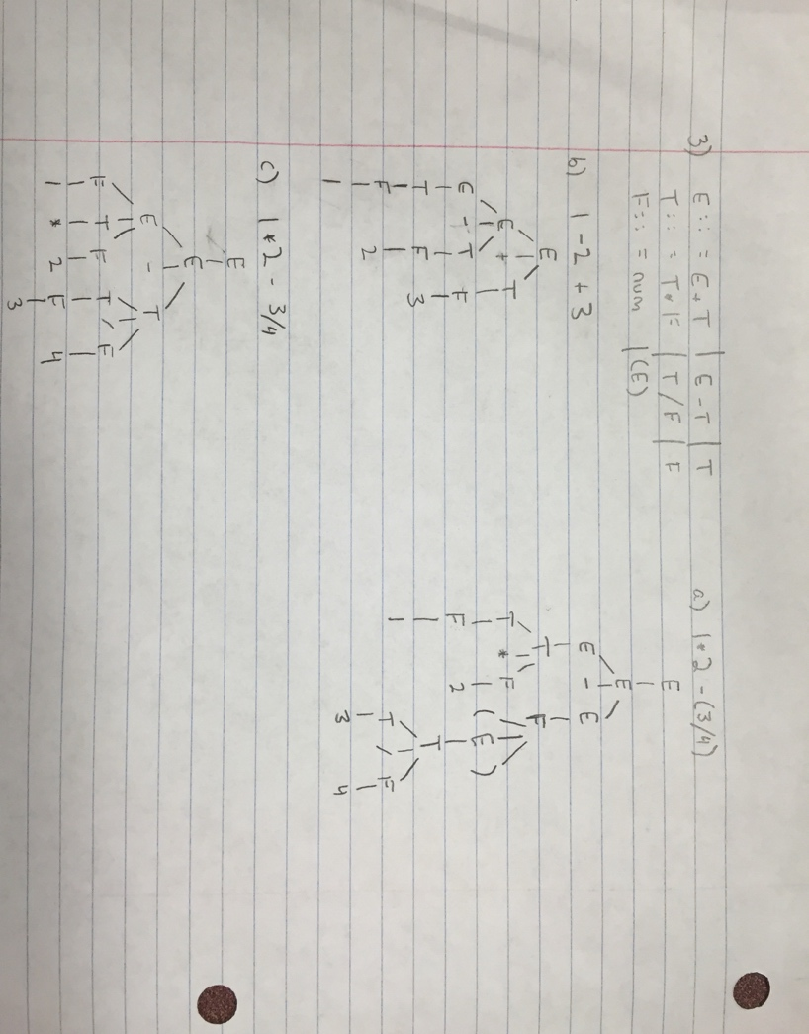

4)

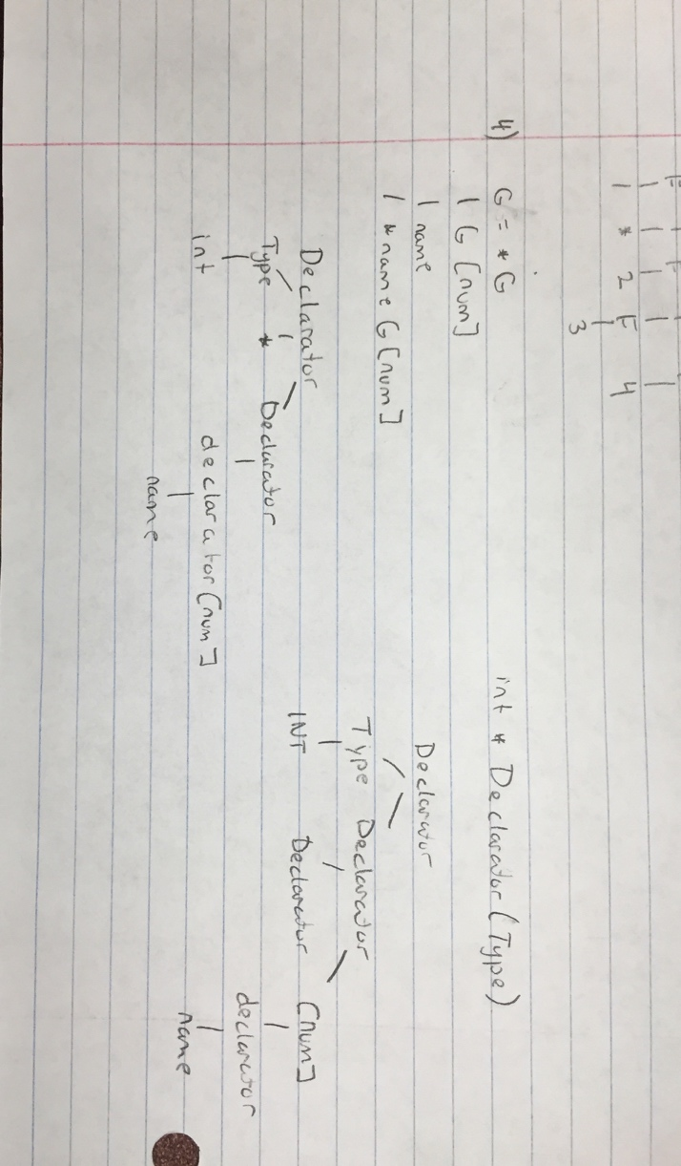

5)

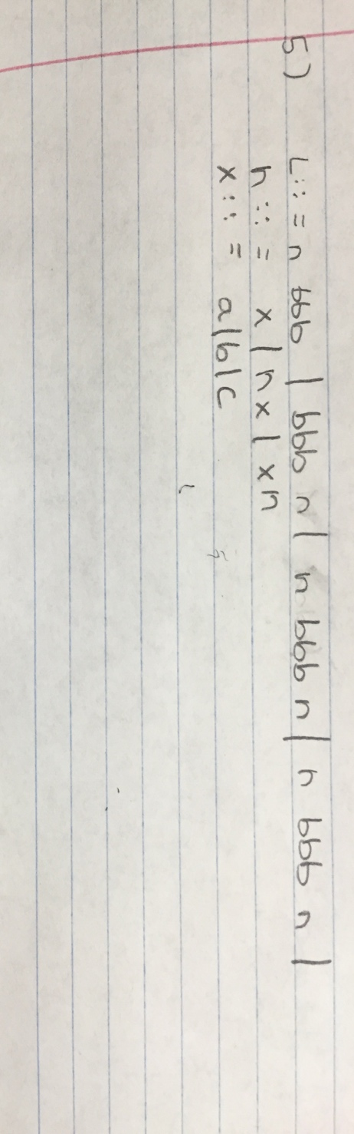

6)

e: = n | x | x := e | e + e

a)

< x + y, σ> →

< 2 + y , σ> →

< 2+3 , σ > →

< 5 , σ >

b)

< x := x + 3, σ > →

< x := 1 + 3, σ > →

< x := 4,σ > →

< 4, σ (x:=4)> c) <( x:= 3)+ x , σ> →

< 3+x, σ (x=3) > →

< 3+3,σ(x:=3) > →

< 6,σ (x:=3) >

d)

< x := (x := x+3) + (x := x+5),σ > →

< x :=(x :=1+3) + (x :=x+5),σ > →

< x :=( x:=4 ) + ( x:=x+5 ),σ > →

< x := 4 + (x := x+5),σ (x=4)> →

< (x:=4 + (x:=4+5),σ(x:= 4)> →

< x := 4 + (x := 9),σ(x := 4)> →

< x:=4 + 9,σ(x := 9) > →

< x := 13, σ (x := 9 ) > →

< 13, σ (x := 13)>